Appendix A: The 5 R’s of Wellbeing
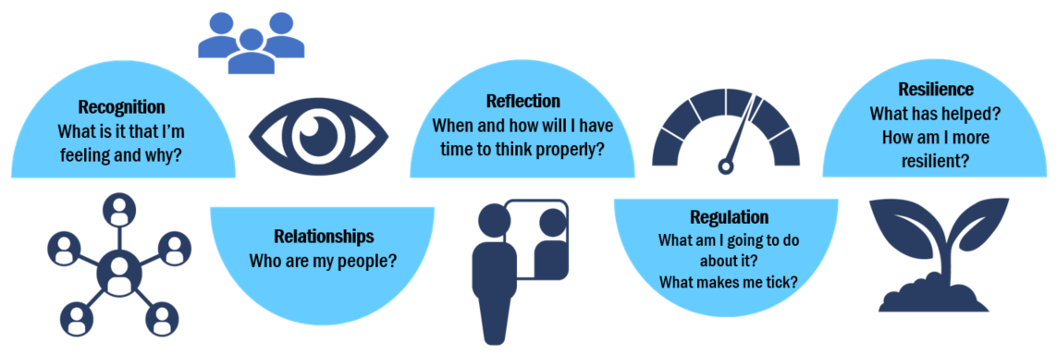
Recognition | Relationships | Reflection | Regulation | Resilience

